**StockMarket API Usage Guide**

**1. Navigate to** [**https://stockmarketinfo.azurewebsites.net/api/stocksymbols**](https://stockmarketinfo.azurewebsites.net/api/stocksymbols)

**2. Enter the user credentials in the login window**

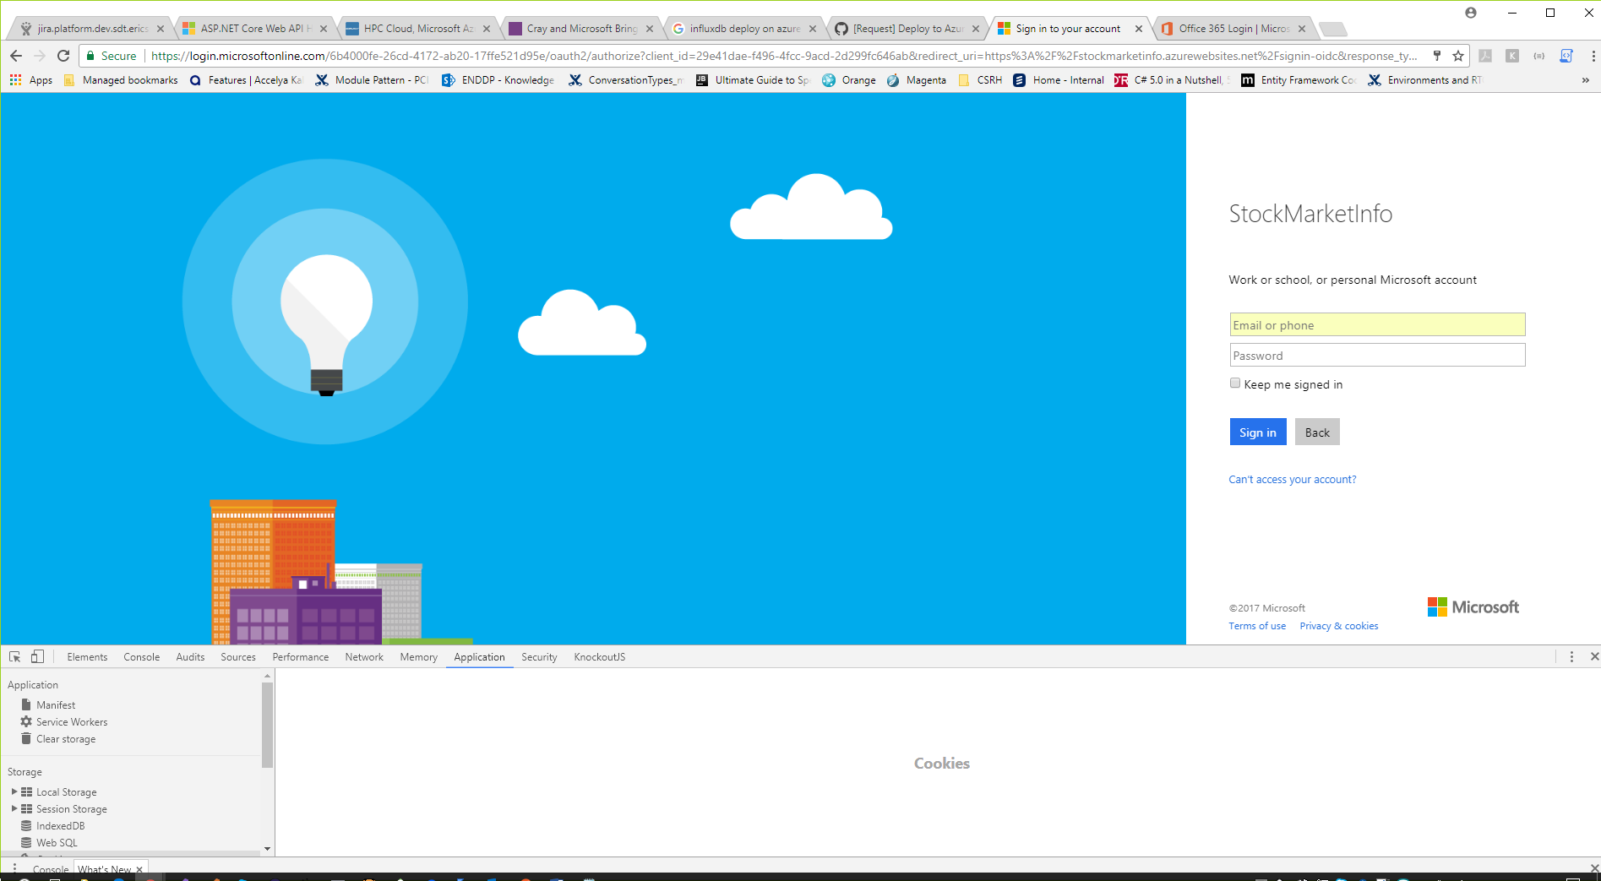

**3. After login procedure the API will be available**

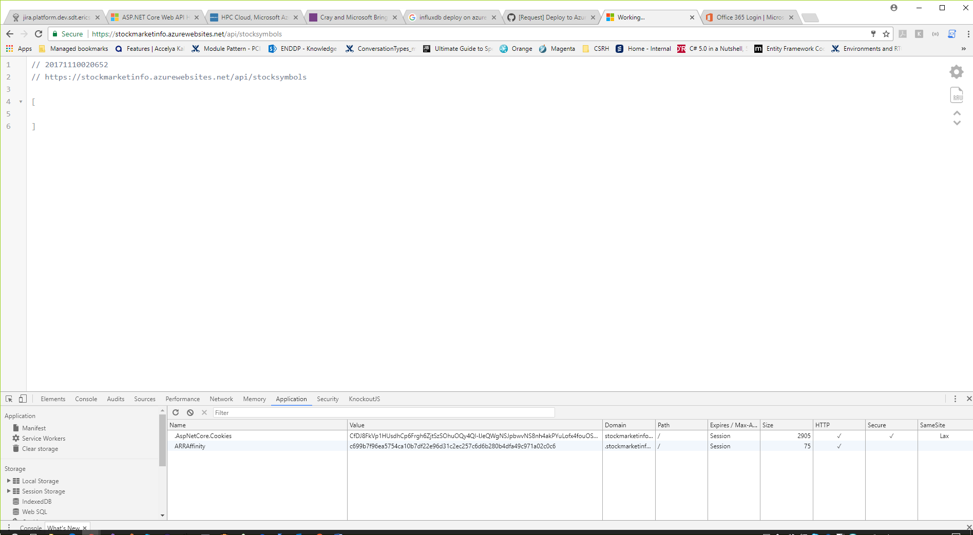

**4. The API description is available by the next link** <https://stockmarketinfo.azurewebsites.net/swagger/>

**5. Configure Postman tool**

**5.1 Add authentication Cookie in the Postman.**

.AspNetCore.Cookies=**value**; path=/; domain=.stockmarketinfo.azurewebsites.net;

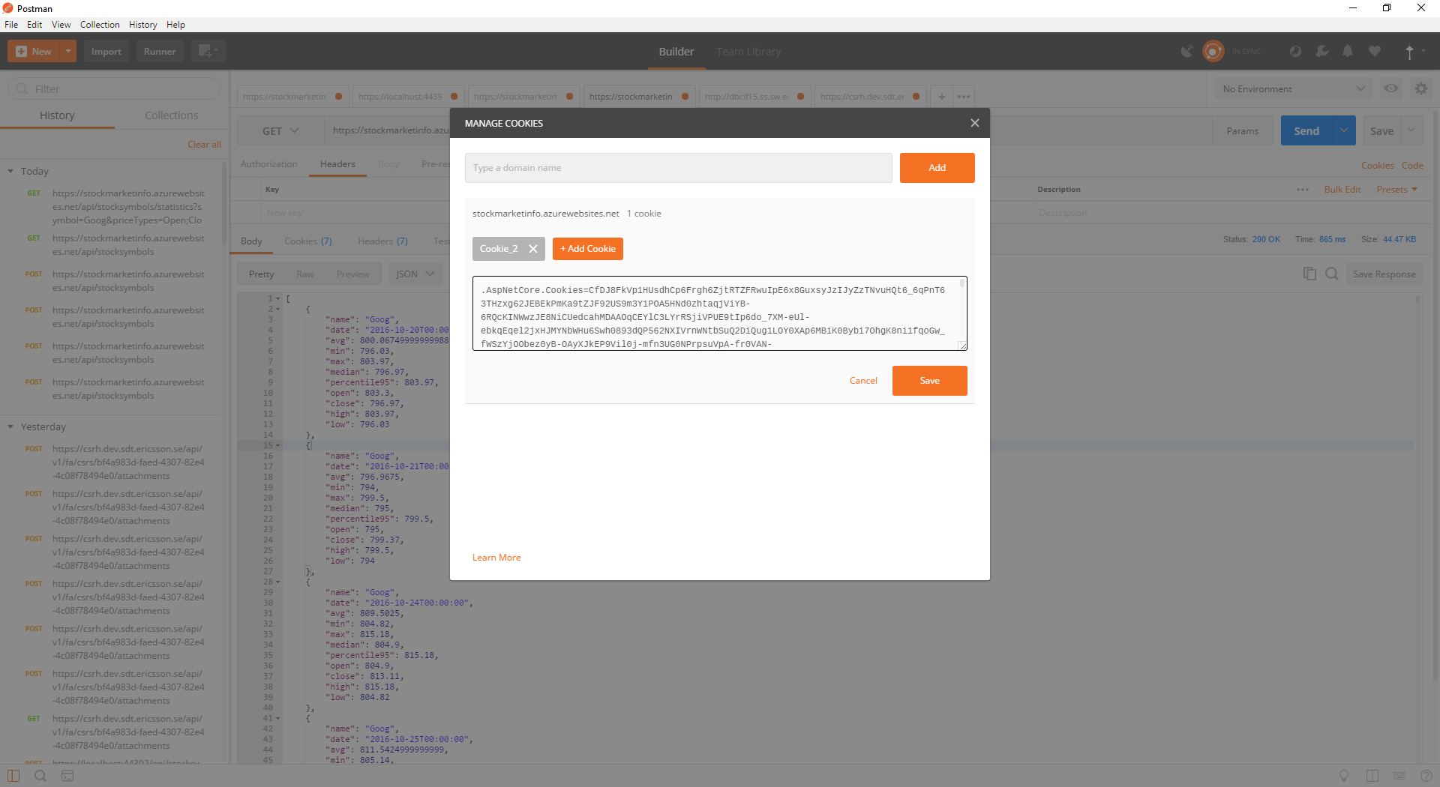

**5.2 To get Cookie value press F12 in the Chrome->Navigate to Application tab->copy the AspNetCore.Cookies value**

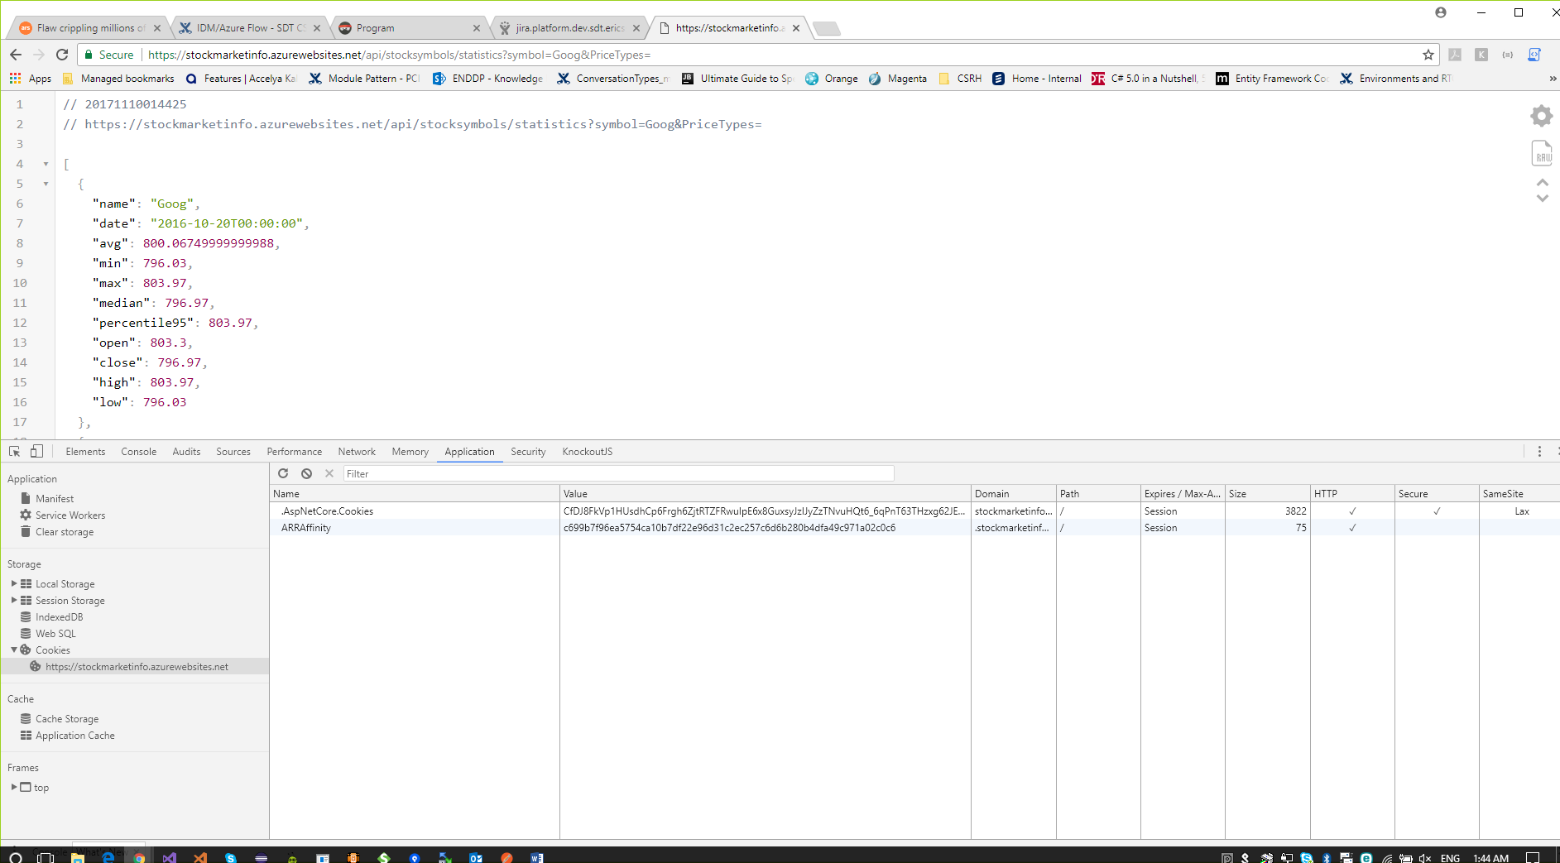

**6. Upload stock market data**

**Request:** POST <https://stockmarketinfo.azurewebsites.net/api/stocksymbols>

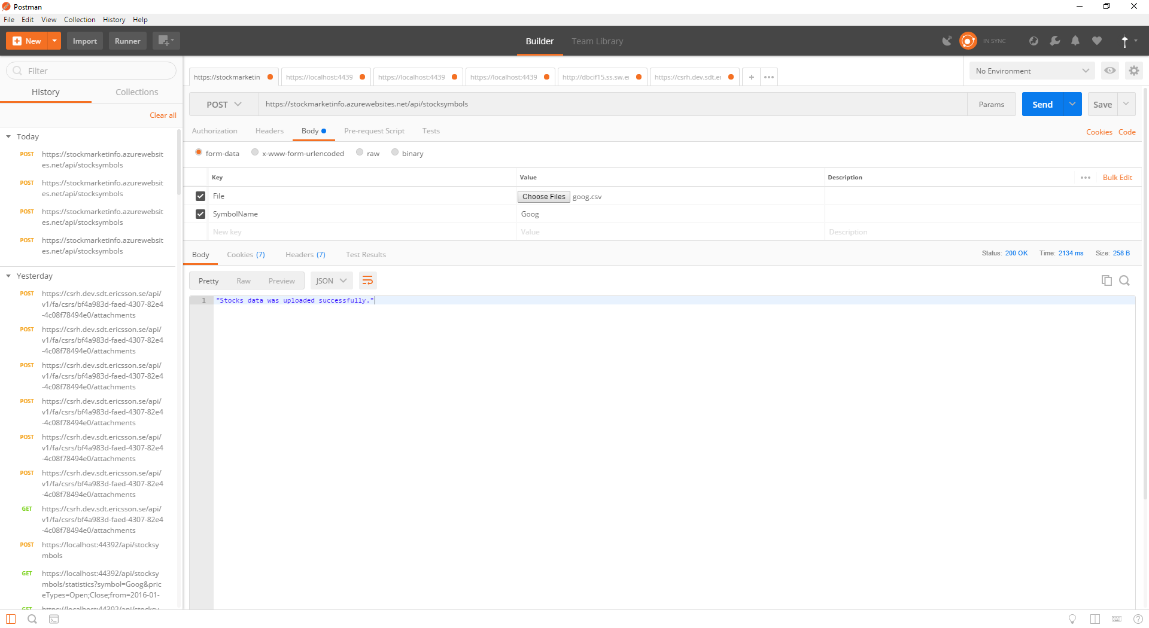

**7. Get available stock market data**

**Request:** GET <https://stockmarketinfo.azurewebsites.net/api/stocksymbols>

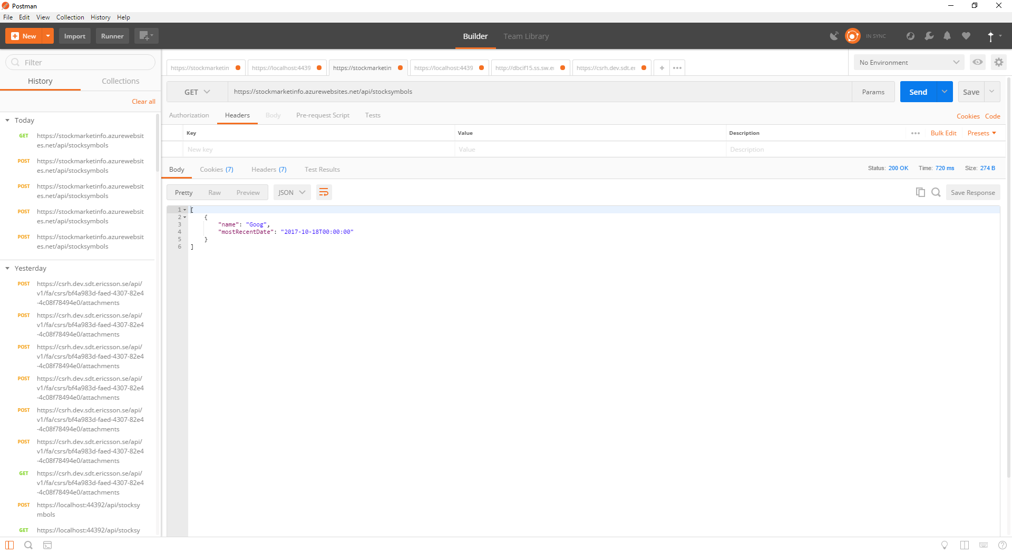

**8. Get available stock market data**

**Request:** GET<https://stockmarketinfo.azurewebsites.net/api/stocksymbols/statistics?symbol=Goog&priceTypes=Open;Close;from=2016-01-01&to=2017-12-31>

